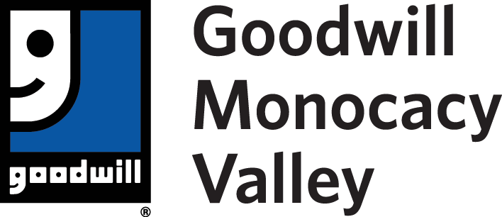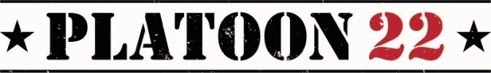

For Immediate Release

For more information, please contact:
Lindsay Hansen
480.205.6195 cell
lindsay@ldhconsulting.net

Goodwill and Platoon 22 Partner to Serve Veterans

PHOENIX, Ariz. (March 3, 2021) — Goodwill Industries of Monocacy Valley and Platoon 22 joined forces in 2019 to build a veteran services center, housed on what will be Goodwill’s new main campus, in Frederick, Maryland. Services provided out of the veteran’s center will focus on supporting veterans and their families and will include several other organizations and programs specifically dedicated to these heroes. The state-of-the-art facility is scheduled to open on Veteran’s Day of 2021 (November 11, 2021).

“The original project broke ground in November 2019 with a community celebration and the two organizations continue to develop plans on how they will serve the community even during these unprecedented times,” said Holly Schor, Vice President of Maryland Operations. “The center will provide access to essential services that will help our veterans smoothly transition to civilian life including benefits navigation, career training and connections to other community resources.”

Goodwill Industries of Monocacy Valley merged with Goodwill of Central and Northern Arizona late 2020. This new opportunity will allow Goodwill to leverage more resources and strengthen our collective impact in the community focusing on services to end poverty through the power of work through career development and training. While there has been a transition in leadership, Goodwill remains extremely dedicated to building the Platoon Veteran’s Center in Partnership with Platoon 22 and collaborating with other organizations to bring best of class services to our warriors, first responders and their families.

“Jen and I have always had a desire to fundamentally change how transitional support is provided to our warfighters, and we have always known that we needed to partner with an organization that could match our vision on a grand scale.” said Danny Farrar, CEO of Platoon 22. “That is why our partnership with Goodwill makes so much sense. We can leverage their scale and ability to provide job and skill training, which is second to none, and couple that with Platoon's proven ability to find and meet the veteran where they are, thus setting the foundation to provide the best in class transitional support for our heroes.”

The entire building is 36,000 (SQ FT) and will house Goodwill regional administration, Goodwill career services, Goodwill training services, an event and meeting space for outside organizations, a retail component and the Platoon Veteran’s Center. While the veteran’s center will focus on services to this population, Goodwill will provide career development and training services available at no-cost to the general public as well.

For more information on the Goodwill Main Campus and the Platoon Veteran’s Center, please check gimv.org

About Goodwill Industries of Monocacy Valley, Inc.
Goodwill Industries of Monocacy Valley, a 501(c)(3) nonprofit organization, provides a wide-array of workforce development programs to residents of Carroll County and Frederick County, Md. Programs include job training, interview preparation, career exploration, digital skills training, and more for job-seekers, veterans, youth ages 14 - 24, and individuals with disabilities. Funding for job training is provided through the sale of donated clothing and other household items. To learn more, please visit www.gimv.org.

# # #

